**NRF24l01 SECOND TEST: Getting started**

**Procedure:**

1. Connect the receiver side NRF first.

2. Upload the Getting started code.

3. The code will put the NRF in Receiver mode by default.

4. The output will be as shown below

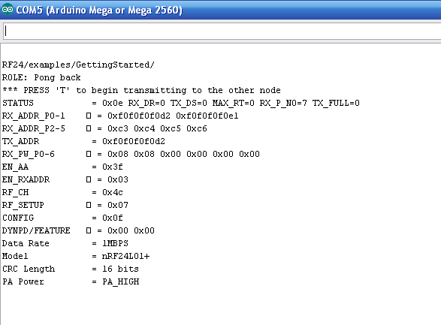

5. Now once you get the shown output connect the transmitter side NRF.

6. Upload the same Getting started code to it.

7. The output will be same as before.

8. Now press ‘T’ in serial monitor to put it in transmit mode

9. The output will be as shown

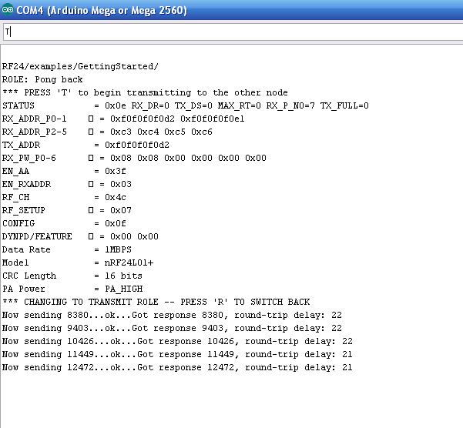

10. Now the Receiver side output will be

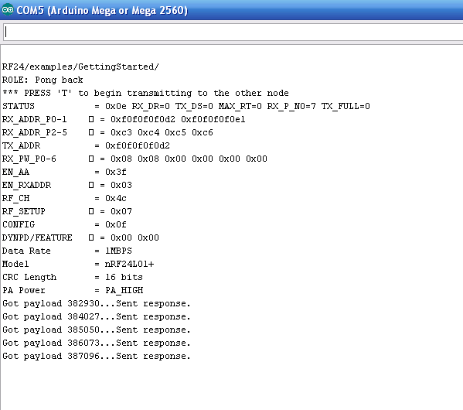

**References:**

You can find the procedure here <https://maniacbug.wordpress.com/2011/11/02/getting-started-rf24/>. and code here <http://maniacbug.github.io/RF24/GettingStarted_8pde-example.html>

**Note:**

1. If you don’t get the output as same as above check the PIN connections in both arduino and CODE.
2. The PIN connections used in the link provided above are for arduino UNO board.
3. If you use another recheck the pin connections for your board here <https://arduino-info.wikispaces.com/Nrf24L01-2.4GHz-HowTo>